Splunk Data Manipulation – Log Parsing and Data Processing

Introduction
Security Information and Event Management (SIEM) platforms such as Splunk rely on properly structured log data. If logs are not correctly parsed during ingestion, security analysts cannot efficiently search, correlate, or investigate events.
This lab focused on improving Splunk’s ability to process raw log data using configuration files and parsing techniques. Several important SIEM engineering tasks were performed, including event breaking, multi-line event handling, sensitive data masking, and custom field extraction.
These tasks simulate real SOC responsibilities where logs from different sources must be properly ingested and structured for security monitoring.

Creating a Splunk Application
To simulate log ingestion, a custom Splunk application named DataApp was created.
Splunk applications provide a structured environment where configurations, scripts, and dashboards can be organized and managed.
The application was created through the Splunk Web Interface under the Manage Apps section and stored in the following directory:

/opt/Splunk/etc/apps/DataApp

This directory contains configuration files and scripts used to control log ingestion and parsing.
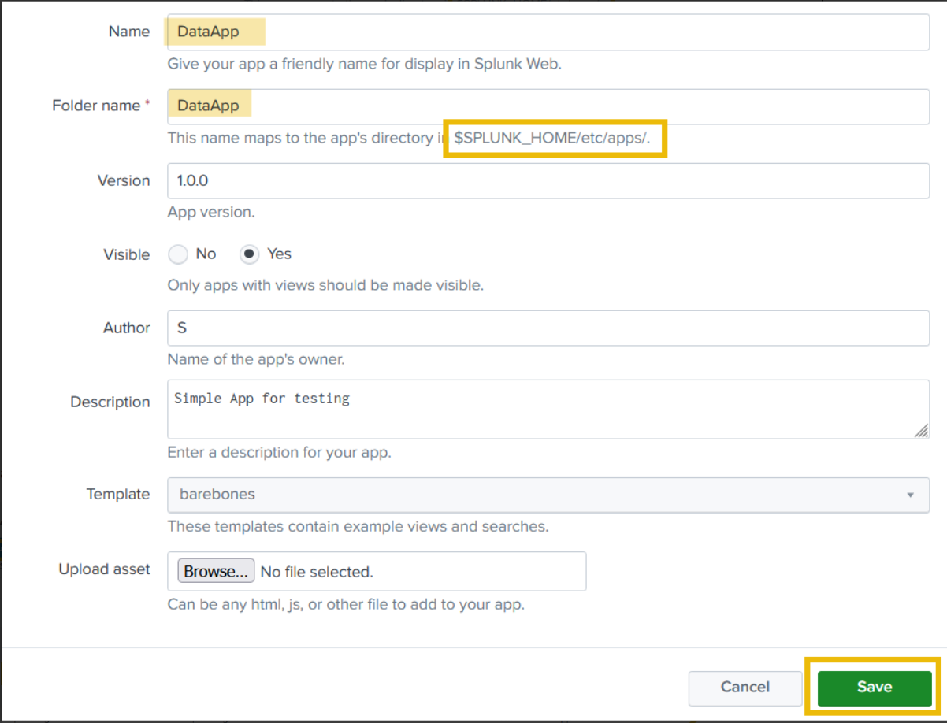

Generating Sample Logs
To simulate incoming log events, a simple Python script was created inside the application’s bin directory.

/opt/splunk/etc/apps/DataApp/bin/samplelogs.py

The script generated test log messages that Splunk could ingest and index.
Example generated event:

This is a sample log...

These logs were used to validate that Splunk could correctly ingest and process incoming data.

Configuring Log Ingestion
Splunk collects data using the inputs.conf configuration file.
The following configuration was added to instruct Splunk to run the script and ingest the generated logs:

[script:///opt/splunk/etc/apps/DataApp/bin/samplelogs.py]
index = main
source = test_log
sourcetype = testing
interval = 5

This configuration executes the script every five seconds and forwards the generated log events to the main index.

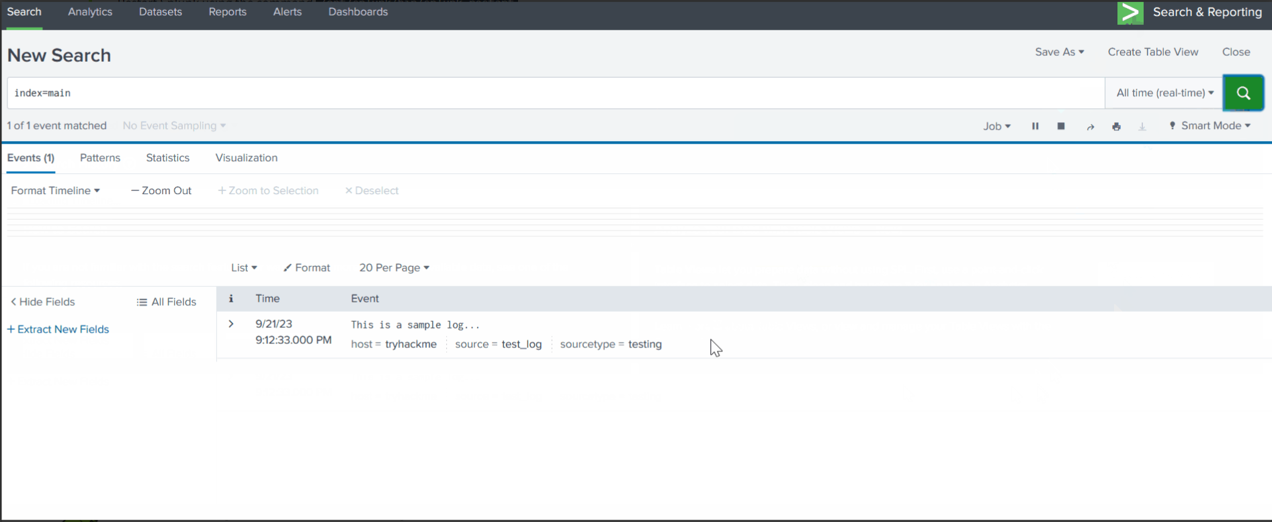

Event Breaking and Log Parsing
Event breaking determines how Splunk separates raw log data into individual events.
Improper event boundaries can cause multiple log entries to be merged into a single event, making investigation difficult.
For example, the following VPN logs were generated:

User: Emily Davis, Server: Server C, Action: DISCONNECT
User: John Doe, Server: Server B, Action: CONNECT

Initially, Splunk incorrectly grouped these entries together.
To resolve this issue, the props.conf configuration file was modified:

[vpn_logs]
SHOULD_LINEMERGE = true
MUST_BREAK_AFTER = (DISCONNECT|CONNECT)

This configuration ensures that Splunk correctly separates each VPN connection event.

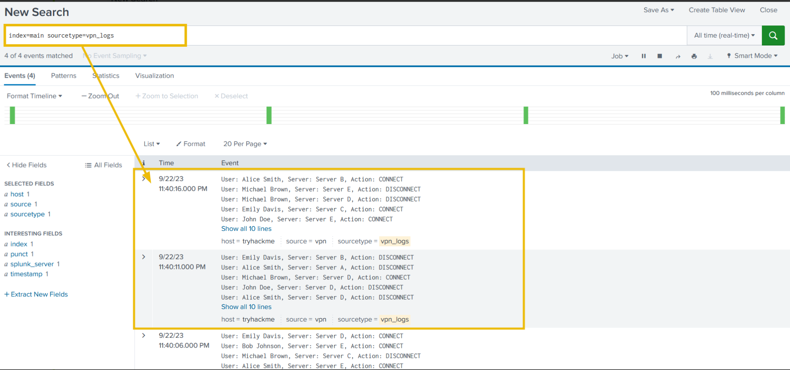

Protecting Sensitive Data
Security logs may contain sensitive information such as credit card numbers. Storing this data without protection can violate compliance standards such as PCI-DSS.
For example, the following log entry was generated:

User William made a purchase with credit card 3714-4963-5398-4313

To protect sensitive information, Splunk’s SEDCMD directive was used to mask the credit card number during indexing.

SEDCMD-maskcc = s/-\d{4}-\d{4}-\d{4}/-XXXX-XXXX-XXXX/g

After applying this rule, the stored log event appeared as:

User William made a purchase with credit card 3714-XXXX-XXXX-XXXX

This ensures sensitive information is protected while maintaining the usefulness of the log data.

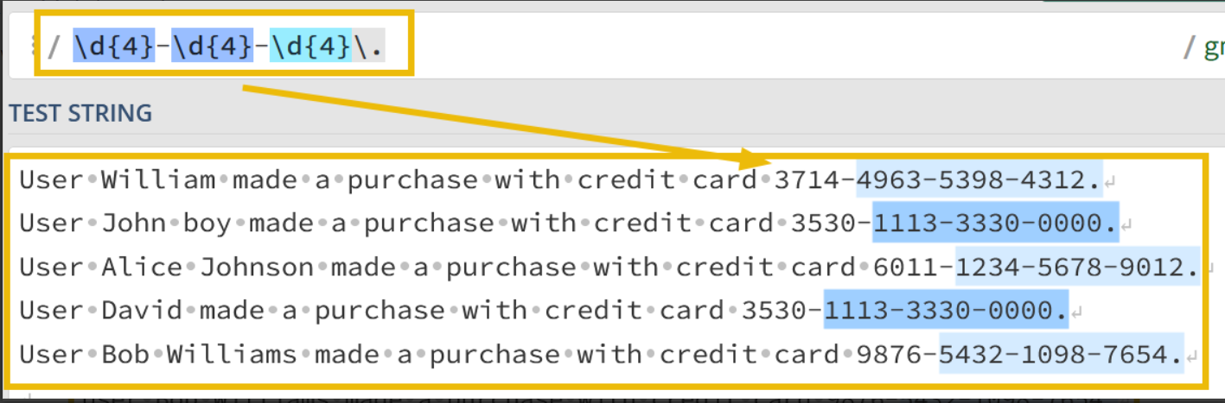

Key Skills Demonstrated
This lab demonstrated several important SIEM engineering skills:
• Configuring automated log ingestion
• Implementing event breaking for structured log parsing
• Handling multi-line log events
• Protecting sensitive information through data masking
• Preparing logs for efficient search and analysis
These techniques are essential in SOC environments where logs originate from many different systems and formats.

Conclusion
This exercise demonstrated how Splunk configuration files can be used to improve log ingestion and parsing.
Proper log structuring significantly enhances a security analyst’s ability to search, investigate, and correlate events across multiple log sources.
Understanding log parsing and data manipulation techniques is a critical skill for SOC analysts working with SIEM platforms such as Splunk.

